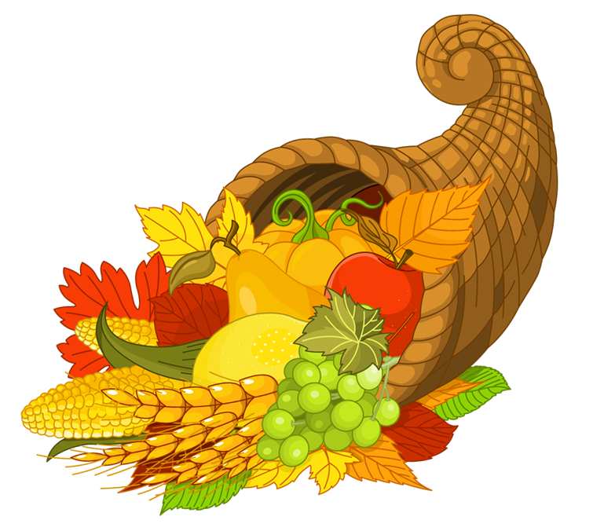  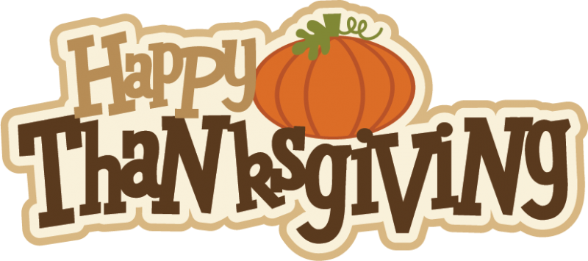  November | 2021
Sunday | Monday | Tuesday | Wednesday | Thursday | Friday | Saturday
 | 1 | 2 | 3 | 4 | 5 | 6
Toddler Time
11:00
7 | 8 | 9 | 10 | 11 | 12 | 13
Toddler Time
11:00
14 | 15 | 16 | 17 | 18 | 19 | 20
Toddler Time
11:00
21 | 22 | 23 | 24 | 25 | 26 | 27
 |  | Toddler Time  11:00 |  | Closed for Thanksgiving | Closed
28 | 29 | 30 |  |  | 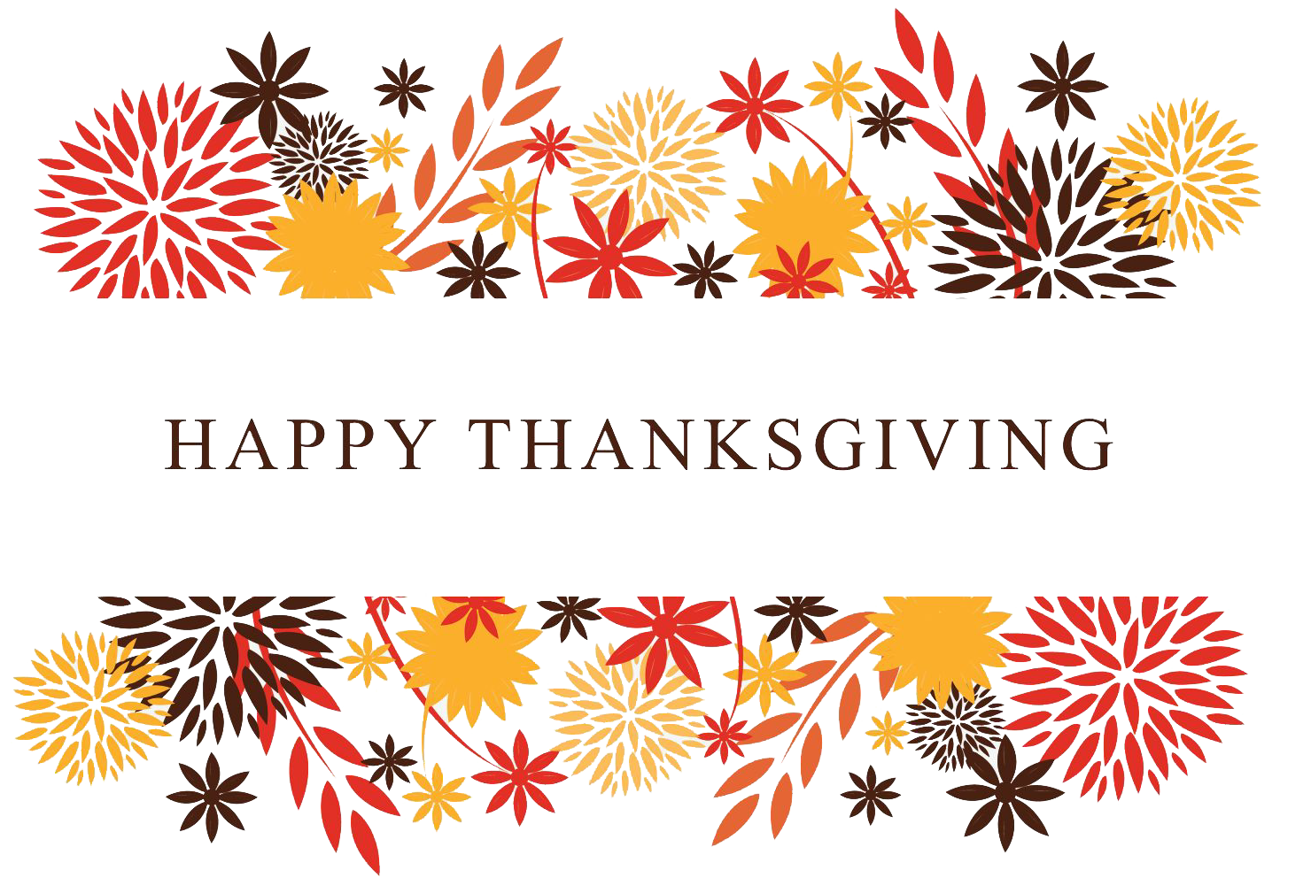
 | Book Club  5:00 | Toddler Time  11:00
 | We will be setting out Take-and-Make Crafts all month!! These will be posted on our Facebook page on the day we hand them out. Follow us on Facebook @huntsvillemadisonlibrary |  | We will still be handing out meals to kids 18 and under after school (provided by Camp Harvest).  Madison County Library  Phone: (479) 738-2754  Email: info@madisoncountylibraries.org
Take-and-Make Crafts

Thankful Tree
Turkey Roll
Fall Leaf Hedgehog
D for Donut Craft
Mayflower Boat
Twine Pumpkin
Acorn Handprint Keepsake
Santa Advent Calendar

